Praktikum 9
SeekBar

1. Buatlah proyek baru dengan Android Studio
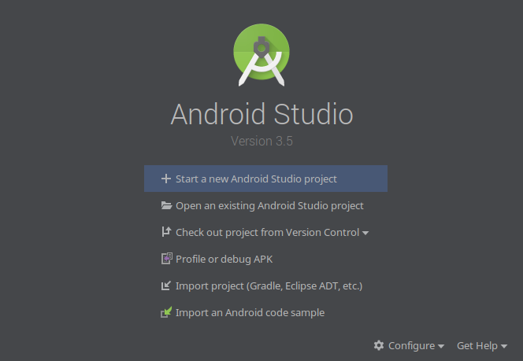

2. Pilih Empty Activity untuk memulai aplikasi baru
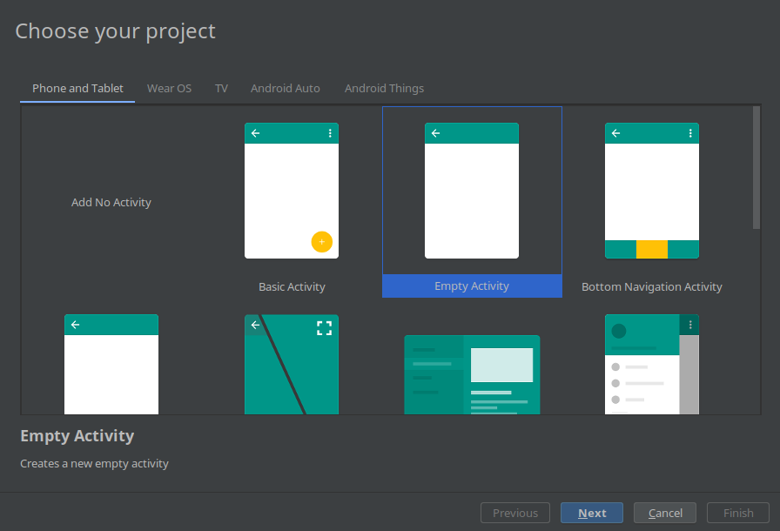

3. Bukalah file activity main lalu edit
<?xml version="1.0" encoding="utf-8"?>
<androidx.constraintlayout.widget.ConstraintLayout xmlns:android="http://schemas.android.com/apk/res/android"
xmlns:app="http://schemas.android.com/apk/res-auto"
xmlns:tools="http://schemas.android.com/tools"
android:layout_width="match_parent"
android:layout_height="match_parent"
tools:context=".MainActivity">
<LinearLayout
android:layout_width="match_parent"
android:layout_height="match_parent"
android:gravity="center"
android:orientation="vertical">
<TextView
android:id="@+id/progress"
android:layout_width="wrap_content"
android:layout_height="wrap_content"
android:text="- -"
android:padding="20dp"/>
<TextView
android:id="@+id/seekbarStatus"
android:layout_width="wrap_content"
android:layout_height="wrap_content"
android:text="- -"
android:padding="20dp"/>
<SeekBar
android:id="@+id/seekbar"
android:layout_width="match_parent"
android:padding="15dp"
android:layout_height="wrap_content" />
</LinearLayout>
</androidx.constraintlayout.widget.ConstraintLayout>

4. Bukalah MainActivity.ky
MainActivity.kt
package com.example.colorpicker
import androidx.appcompat.app.AppCompatActivity
import android.os.Bundle
import android.widget.SeekBar
import android.widget.TextView
import kotlinx.android.synthetic.main.activity_main.*
class MainActivity : AppCompatActivity(), SeekBar.OnSeekBarChangeListener {
private var progressView: TextView? = null
private var seekbarStatusView: TextView? = null
private var seekbarView: SeekBar? = null
override fun onCreate(savedInstanceState: Bundle?) {
super.onCreate(savedInstanceState)
setContentView(R.layout.activity_main)
progressView = this.progress
seekbarStatusView = this.seekbarStatus
seekbarView = this.seekbar
seekbarView!!.setOnSeekBarChangeListener(this)
}
override fun onProgressChanged(seekBar: SeekBar, progress: Int, fromUser: Boolean) {
progressView!!.text = progress.toString()
seekbarStatusView!!.text = "Mendeteksi Sentuhan"
}
override fun onStartTrackingTouch(seekBar: SeekBar) {
seekbarStatusView!!.text = "Memulai Deteksi"
}
override fun onStopTrackingTouch(seekBar: SeekBar) {
seekbarStatusView!!.text = "Berhenti Deteksi"
}
}

5. Kompile Program

